**S-100 TSM7-4.8**

**Paper for Consideration by S-100 WG TSM7**

**Approach of interoperability of S-100 products and ECDIS**

|  |  |
| --- | --- |
| ***Submitted by:*** | France (Shom) |
| ***Executive Summary:*** | Provides inputs and analysis elements to explain how S-100 products should interact together in a S-100 ECDIS based on use cases |
| ***Related Documents:*** | Draft S-98 |

**Introduction / Background**

At HSSC11, S-100 Test Strategy Meeting (TSM) was tasked, in liaison with IEC, to develop Ed.1.0.0 of S-98 further taking into account the recommendations provided in document HSSC11-04.8A, the possibilities offered by the development of back-of-bridge/front-of-bridge concepts, and provide inputs as appropriate for the development of the S-100 Implementation Strategy.

**Analysis/Discussion**

This paper provides in the annex some inputs to be discussed:

1. use cases on a bridge:

This is an analysis of international guides on navigation. It defines the requirements and tasks of the officer of watch during the voyage. The two use cases: voyage planning and monitoring / execution of voyage planning are defined. A mapping between information needed for navigation and S-100 product specifications is proposed.

2. concept of back of bridge and front of bridge:

IMO documentation and use cases enable to propose a more precise definition of the concept of back of bridge and front of bridge. It is the result of the combination of the use cases and the practical layout on the bridge.

3. S-100 PS to be considered:

In line with the use cases, a list of information needed in front of bridge is proposed. The appropriate S-100 products are associated. Priority in the development of S-100 PS and S-98 should be given to the front of bridge. The coordinated development of S-100 PS by the different WGs should reach a global harmonized display of data in ECDIS, clearly understood by the end-user: a coordinated display should imply a well-thought-out analysis of how the different S-100 PS (combination to be defined according to the use cases) can be displayed together, and what the end-user needs to see. Requirements on display should be identified and defined in S-98 to be integrated in the implementation by the OEMs.

**Action Required of TSM**

TSM is invited to note this paper and discuss its proposal.

**ANNEX – INPUTS and ANALYSIS**

# IMPLEMENTATION PRINCIPLES OF S-100.

Before any further development on S-98, the following approach is proposed to ensure that the needs of end-users are met. An approach top-down (from end-users needs to technical concepts) should set the construction of S-100 and the principles of interoperability of S-100 products on a sound basis.

Needs, use cases, systems, products are closely linked. The development of S-100 and by extension, S-98 should seek a full consistency.

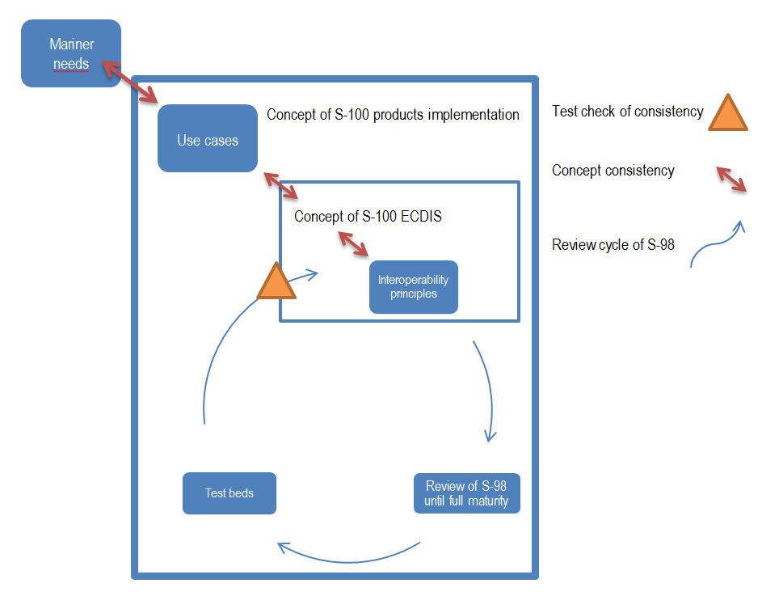

# Use cases.

In e-navigation concept, two scopes are defined: the ship side and shore side services. The S-100 concept meets the need for a Common Maritime Data Structure (CMDS). The proposed approach only focuses on the ship side. In the literature (regulation, navigation guide, study on e-navigation), navigation is defined according to two functionalities: *voyage planning* and *execution of voyage plan and others officer of watch (OOW) tasks*, often summarized as “route monitoring”. The role of the future ECDIS on the bridge has to be defined regarding these two functionalities in accordance with IMO regulations. Identification of use cases on bridge is needed to answer which S-100 products are expected for ECDIS and for other bridge equipment. We are in the case of human navigation, but the approach is not in conflict with the emerging autonomous ship navigation.

According to the bridge procedures guide of the international chamber of shipping, the four stages to achieve a safe passage plan is:

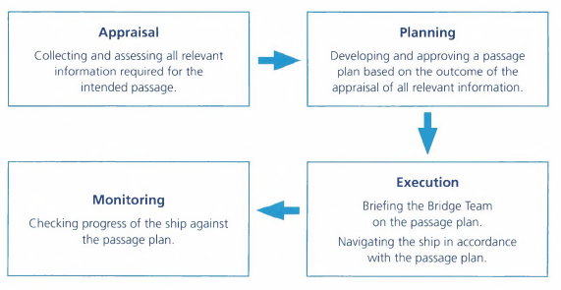

*Use cases of the officer of watch on bridge – reference [4].*

These four steps can be summarized in two use cases: the voyage planning and the monitoring / execution of voyage planning, as defined in IMO regulations.

## Voyage planning.

This activity is usually performed in a relatively quiet area, on the back end of the bridge, on a chart table. It is done ahead of departure or can be conducted during long ocean passage. The officer of watch gathers the information needed for the voyage plan from berth to berth: it is various in formats, relevance and frequency of updating. He is normally available to spend a reasonable amount of time to understand information at his disposal to prepare his route: sorting, analysis, selection of a travel planning scenario. It may require reading literature, if the information is not directly understood; he has the possibility to read it again, to analyze and to do a cross-reference between different information. With S-100 products, most of the information becomes georeferenced-information. Cross-reference process is more efficient.

ECDIS in route planning mode is the regulated system for designing and checking the planned route.

The OOW needs the following information:

* Cases of ocean routes:
* Climatological and oceanographic seasonal conditions, ocean currents, ice limits, load lines
* Meteorological information
* Services for weathers routeing
* Environmental protection measures
* Ship’ routeing and reporting system, VTS
* Navigational warnings
* Volume of traffic likely to be encountered
* Landfall conspicuous landmarks
* MSI services and communications
* Regulatory areas : Emission control areas
* Cases of coastal routes:
* Charted features and other features for safe distance
* Available depth of water including tidal water level information
* UKC requirements and other limiting conditions
* Currents, tidal currents
* Landmarks and AtoNs, availbility of visual and radar fixing opportunities
* Recommended routes and channel information, local conditions and restrictions on navigation, trafic likely to be encountered
* Navigational warnings
* Pilotage requirements and services, procedures (a pilotage plan is required)
* Port requirements, port facilities, procedures for port entry
* Reporting et communication procedures
* Details of the prospective berth and anchorages
* Meteorological information
* Environmental protection measures
* Ship’ routeing and reporting system, VTS
* MSI services and communications
* Cases of berthing / pilotage
  + Arrival intentions including embarkation time, arrangements for cargo discharge and bunkering
  + Communications should be established with Pilot, port VTS and port authorities as appropriate.
  + Pilotage plan subject of Master/pilote information exchange (MPX)
  + Updates on local conditions such as weather, depth of water, tides and tidal streams, traffic conditions
  + Information on berthing arrangements including the use, characteristics and number of tugs, mooring boats, mooring arrangements and other external facilities;

## Execution of the voyage plan / monitoring.

This task is performed at the front of bridge, as the OOW needs to have a control view of the environment, specially, when the ship is approaching harbor and entering coastal waters. He normally executes the voyage planning previously defined. The voyage plan is normally stored and can be followed on an ECDIS (route monitoring mode) integrated in an INS (Integrated Navigation System). The need of synthetic, unambiguous and clear information is essential, as its decision-making needs to be rapid in the face of any events that may occur (anti-collision, anti-grouding). It is necessary to reduce the number of manipulations to be carried out on the system (ECDIS) and reduce its mental workload as much as possible.

A part of the monitoring can be done by ECDIS:

* + The ship ’s current position and proximity of dangers to navigation,
  + The intended track (passage plan), course and speed, XTD
  + The traffic situation and the traffic density to be encountered
  + The vessel reporting requirements completed or due
  + The environmental requirements
  + Weather conditions to be encountered including sea state and visibility
  + Navigational hazards uncharted to be encountered

The OOW should:

* Follow the passage plan and monitor the progress of the Ship
* Make a full appraisal of the risk of collision with other vessels;
* Identify navigational hazards such as wrecks, floating objects, ice and uncharted hazards;
* Determine the risk of grounding or stranding (UKC);
* Detect and respond as appropriate to any significant change in the weather, visibility or sea state
* Identify navigational marks
* Position fixing of the ship by all appropriate means
* Take action to avoid collision
* Amend the passage plan
  + permanently (the passage planning phase is repeated) - Causes : weather routeing developments – change of destination – SAR response
  + deviation – causes: COLREG, variations of weather conditions, advice received from VTS – NWs, dectected hazards.
* GMDSS watchkeeping (radio, emergency, MSI, routine and general comm)

# Concept of front of bridge and back of bridge.

The concept of front of bridge and back of bridge appears in some studies relative to e-navigation. The IMO document referenced in [2] on bridge ergonomics describes how a bridge should be spatially organized. Without mentioning the term, this is the prelude of the concept of front and back of bridge. The planning and documentation workstation includes an ECDIS.

ECDIS monitoring mode

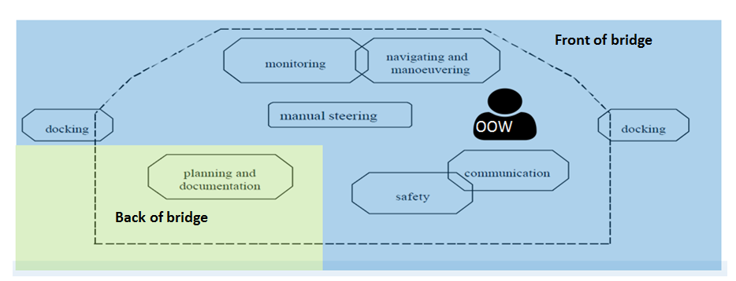

ECDIS planning mode

*Edited schema of the bridge presented in Guidelines on ergonomic criteria for bridge equipment and layout - reference [2].*

The study in [5] describes the bridge that fairly well corresponds to a design found on many modern ships. The back of bridge is equipped with an electronic chart table, which is still in coming. It will be an appropriate format for nautical information with space offering the advantage of the overview similar to paper charts, together with the layering and dynamics of digital information. As voyage planning is a function of the ECDIS, we have to consider that an ECDIS can be in back of bridge, even if in the present modern ships, we can mainly find ECS.

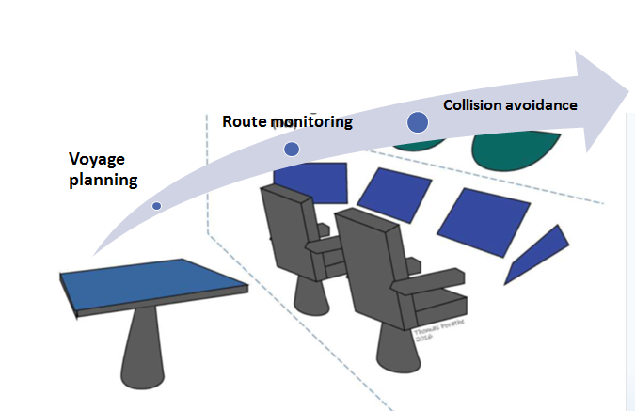

*Edited schema of the three different contextual control levels supported by different information displays and human machine interfaces in different locations on the ship bridge – reference [5].*

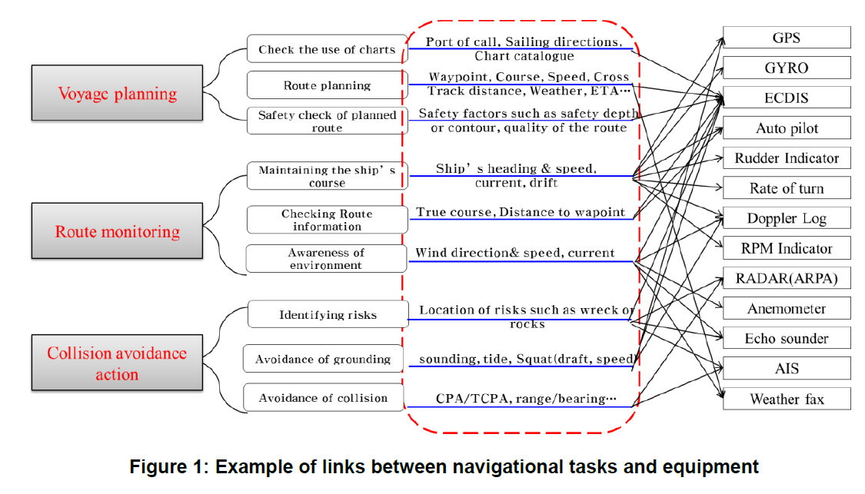

*Example of links between navigational tasks and equipement – reference [6]*

**It is proposed that TSM defines on paper the concept based on IMO documentation and to study if it is needed to define how information and road can be exchange between front of bridge and back of bridge.**

# information, products and services needed for front bridge.

## Information needed for the officer of watch.

The following table defines for each tasks of the officer of watch, the needed information when he executes the voyage plan. When relevant, the appropriate S-100 product is associated.

|  |  |  |
| --- | --- | --- |
| **Tasks of OOW in front of bridge** | **Information** | **S-100 products** |
| Follow the passage plan and monitor the progress of the Ship | Route, GNSS, chart, voyage plan | S-101 |
| Make a full appraisal of the risk of collision with other vessels | GNSS, AIS, radar | / |
| Identify navigational hazards such as wrecks, floating objects, ice and uncharted hazards; | Chart, navigational warning, sea ice observations | S-101  S-124  S-411 |
| Determine the risk of grounding or stranding (UKC); | Chart, high density bathymetry, UKC, voyage plan | S-101  S-102  S-104  S-129 |
| Detect and respond as appropriate to any significant change in the weather, visibility or sea state | Weather forecasts | S-412 |
| Identify navigational marks | Chart, voyage plan | S-101 |
| Position fixing of the ship by all appropriate means | Chart, radar | S-101 |
| Take action to avoid collision | GNSS, chart, voyage plan | S-101 |
| Amend the passage plan permanently (the passage planning phase is repeated) - Causes : weather routeing developments, change of destination, SAR response deviation, COLREG, variations of weather conditions, advice received from VTS, NWs, dectected hazards. | Chart, SAR information, weather forecast, NW, VTS information | S-101  S-111, S-112, S-124, S-411, S-412 … |
| GMDSS watchkeeping (radio, emergency, MSI, routine and general comm) | Chart, voyage plan | S-101 |

## Products and services implied in front of bridge.

* S-101:

The officer of watch needs a full synthetic product showing almost-permanent (static) geo-information for navigation that eases dissemination and reduces the workload on bridge. S-101 ENC is the relevant product that meets this requirement. No other product can functionally replace S-101.

Products other than S-101 deals with dynamic information, often issued locally by authorities, in a very short notice or even in real-time. One of the use case is the broadcast of refreshed local high resolution bathymetry when ships are navigating and approaching their destination. According to the previous table, the following existing or under development S-100 products dealing with a dynamic flow with frequent updating are listed below:

* Real-time hydro and environmental information:

S-104 : water level information

S-111 : surface currents

S-112 : dynamic water level data

S-124: navigational warnings

S-411: sea ice overlay

S-412 : weather overlay (forecasts)

* Go-No Go areas and other information provided by local UKCM dynamic system

S-129 : UKCM derived from S-104 and S-102

* High density bathymetry:

S-102 : bathymetric surface

This list is not complete and it is proposed that TSM study whether the gap should be supplemented by non-developed S-100 products (for example, SAR information that is not an IHO-product).

|  |  |  |  |
| --- | --- | --- | --- |
|  | Static | Dynamic | |
|  |  | Prediction, forecasting | Observation |
| S-101 | X |  |  |
| S-104 |  | X | X |
| S-111 | X (in competition with S-101) |  | X |
| S-112 |  |  | X |
| S-124 |  |  | X |
| S-411 |  | X | X |
| S-412 |  | X |  |
| S-129 |  | X | X |
| S-102 |  |  | X |

*Filled table according to use cases of product specifications.*

* S-129 :

In line with the use case defined in S-129: *“Immediately before entering the UKCM area and whilst underway, the use case changes again to become the actual plan and more up-to-date information is required, approximately every five to ten minutes. In this case, it is likely that the whole information in the dataset needs to be updated – including the route, the go/no-go areas and the 'parent' UnderKeelClearancePlan feature. The dataset will be updated based on latest observed and forecast conditions, and (optionally) actual ship position, heading and speed (e.g. as received in a UKCM service via AIS). S-129 datasets are typically intended to be overlays to ENC and always displayed with ENC data in the background. Systems that support the display of S-129 datasets should provide the user with easy functions to turn the display of S-129 datasets on and off”,* S-129 firstly is considered in the voyage planning then is updated as the ship gets closer to the deadline of berthing. S-129, firstly based on predictions, can be updated at the last minute with accurate observations. S-129 takes into account the interoperability for the following IHO S-100 based specifications: S-102 and S-104. The use case defined in the product specification is clear and S-129 contributes to the voyage planning but also during monitoring mode. **It is proposed that TSM approves the integration of S-129 in S-100 products for monitoring and explains its use case in ECDIS**.

* S-102 :

S-102 should be reported as a navigation product. Metadata exists to indicate if the product can be used for navigation safety purposes. If not, S-102 is to be considered as an exchange format. S-102 (+S-104), as currently defined, is a product that can be easily interpreted by the machine, but it is more difficult for humans to interpret the bathymetric model in terms of safety: shoals are not exaggerated and can’t be visible to the naked eye – even more if colors used in S-101 and S-102 portrayal are similar - although it provides a better perception of the morphology of the bottom. This is a different case of interoperability between products that must be well-displayed and those that are important for navigation but must be interpreted by the machine, such as the UKC. At the end, S-102 without any other layer may have a limited interest because the ultimate purpose is to make UKC. The question of the positioning between the S-102 and S-129 arises.

For that reason, S-102 should not completely replace bathymetry of S-101.

* Discrepancy S-101 / derived-bathymetric products:

S-102 and S-129 should be considered as added value overlays enhancing navigation, but in the UKCM areas, the mariner will use S-129 product calculated with a bathymetry that may be inconsistent with the ENC (possibly not up-to-date at the same frequency). **The value (including legal value) of S-102, S-129 should be clarified as soon as possible to resolved the case of discrepancy between S-101 and others bathymetric products.**

## Development priorities.

The development of S-100 products is made in pipeline, although S-100 products are likely to be used in combination. An overall consistency should be reached between the S-100 products, but also with the other information (AIS, target), in accordance with the S-mode. Use cases should be specified to prioritize developments and define combinations.

**It is proposed to TSM to study in priority how S-100 products implied in front of bridge should interact together on ECDIS.** These products should be the priority in the development of S-100 and their interoperability managed for the following reasons:

* Information in the front of bridge are essential for the OOW ;
* The front of bridge is more critical and the requirements on ergonomic display are higher ;
* Information in the front of bridge makes more sense when displayed on a chart ;
* It is the easier case (but the most demanding), as only a limited list of products is to be considered ;
* For the OOW, this the use where there is the most added value.

## Global harmonized display.

Interoperability also involves portrayal. It may be interesting to define a common portrayal base to avoid display conflicts. As ECDIS is one of the means improving safety at sea, the human factors and ergonomics should be considered. A cognitive approach should be used for a better understanding by the end-user of the information displayed on an ECDIS.

Portrayal of S-100 products has been developed individually while the products are intended to be used together in a harmonized display: management of pick reports, colors, symbol, display priorities depending of the criticality of information, transparency…

We can wonder if OOW should understand at first sight which kind of data (static, dynamic, from which product) are displayed. As a first approach, not necessary, the OOW should normally be fully aware of the information available to it on ECDIS. But on the other hand, it’s difficult to apply that principle for some PS (for example S-111) as the same product is used for two types of data: prediction or observations. As it is essential to reduce mental workload when visualizing an ECDIS, this case should be solved with care.

**A global harmonized display of data in ECDIS should be reached**: a harmonized display should imply a well-thought-out analysis of how the different S-100 PS (combination to be defined according to the use cases) can be displayed together, and what the end-user needs to see: which information should be visually differentiated (in relation to S-101 portrayal), is it useful to display the full coverage or the entire content of the S-100 product, or only the added value of the product?

See below the example discussed by the TWCWG and NIPWG on the combined use of dynamic S-111 current and the current officially delivered for navigation by ENC (e.g. S-101) the two information are different by nature : one is dynamic, the other is static (for example, mean spring water). The critical issue is how to display and manage these two information without display overloading and confusing the mariner. One of the discussed solutions is to define alert (warning pop-up) when there is a high difference (threshold to be defined) useful for safety of navigation. In metadata, the source of the information (stat, real time, etc. ,) is defined in the product (S-111). It implies that metadata should therefore have to be read and understood by the ECDIS and alert management system to avoid that the OOW interpret and analyze among the different products available. This is a good example of the difficulty to manage all the information.

S-98 should define the principles of how the different S-100 product specifications should interact together and how they are displayed in the ECDIS. These principles should be strong requirements to be developed by OEMs in the ECDIS. It ensures that S-100 provides end-to-end solutions for the end-user.

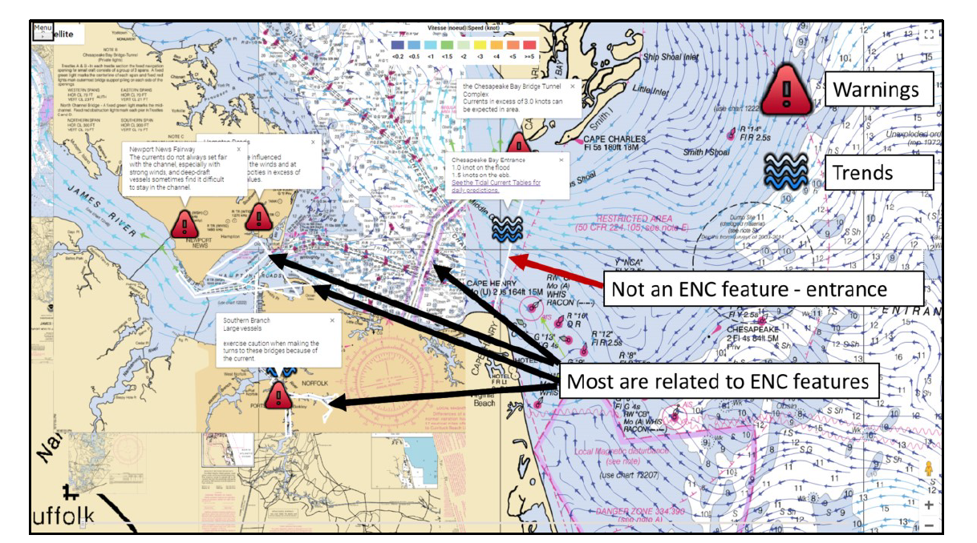

*Prototype from UNH – TWCWG4*

# back of bridge.

## Interoperability in back of bridge.

In back of bridge, the number of combinations can be exponential, depending on the number of products and the level of interoperability. In any case, interoperability should be limited basic and intuitive functions from the point of view of the mariner, in order to understand what it is displayed on ECDIS. It is probably not compatible with the high number of combinations. Looking at today's ECDIS, it seems difficult to imagine how ECDIS will be able to manage all layers. The back of bridge should be a joint use of the ECDIS (for the regulated task of voyage planning) and an ECS, offering more flexibility in the display configuration (but more time consuming).

## Consistency of nautical publications range in back of bridge.

The nautical publications have been divided into thematic slices (S-1xx) which support the idea of scattered flows from different shore services. The workload of the OOW to identify, collect and merge on board all the relevant information will increase, as information can be provided by different producers: HOs of course, whose role is to produce nautical products, but also high-developed port services (VTS, HR bathymetry). The intended purpose is not to increase the work for the end user.

There is also a high risk to lose the primary functions of the product. For example, for sailing directions, this is a sum of themes and the combination of this information provides the advice. Sailing directions, with the joint use of the nautical chart, explains navigation environment and provides additional information to the chart. The wordiness of sailing directions could be reconsidered in an ergonomic approach where the combination of the display of geographical objects in various thematic layers becomes the information. It is difficult to see how the primary functions of sailing directions can be fulfilled if the mariner does not buy all the layers or if the combination doesn’t interact together. Distribution of S-100 products is thematic rather than focused on use; the mariner will lose the synthetic approach of the present nautical products. Probably, this will not simplify his work.

**References**

[1] IMO (25 Novembre 1999), Guidelines for voyage planning, resolution A.893(21)

[2] IMO (20 December 2000), Guidelines on ergonomic criteria for bridge equipement and layout, MSC/Circ.929;

[3] IMO (5 December 2006), Resolution MSC.232(82) – adoption of the revised performance standards for electronic chart display and information systems (ECDIS)

[4] International chamber of shipping (2016), Bridge procedures guide, (5th edition), London

[5] European project EfficienSea2, D6.8, report on human factors aspects of e-Nav Services.

[6] IMO (13 November 2018), Guidelines on standardized modes of operation, S-mode, Practical user interface test methods for standardization and improvement of navigation equipment Submitted by the Republic of Korea

[7] IMO, Guidelines for the standardization of user interface design for navigation equipement – draft MSC circular